***Systems Biology***

***Assignment – 4***

*-BS19B032*

*-R. Vasantha Kumar*

Problem 1:





Problem 2:

a) I simulated the three node repressilator, using the given conditions. The output is:

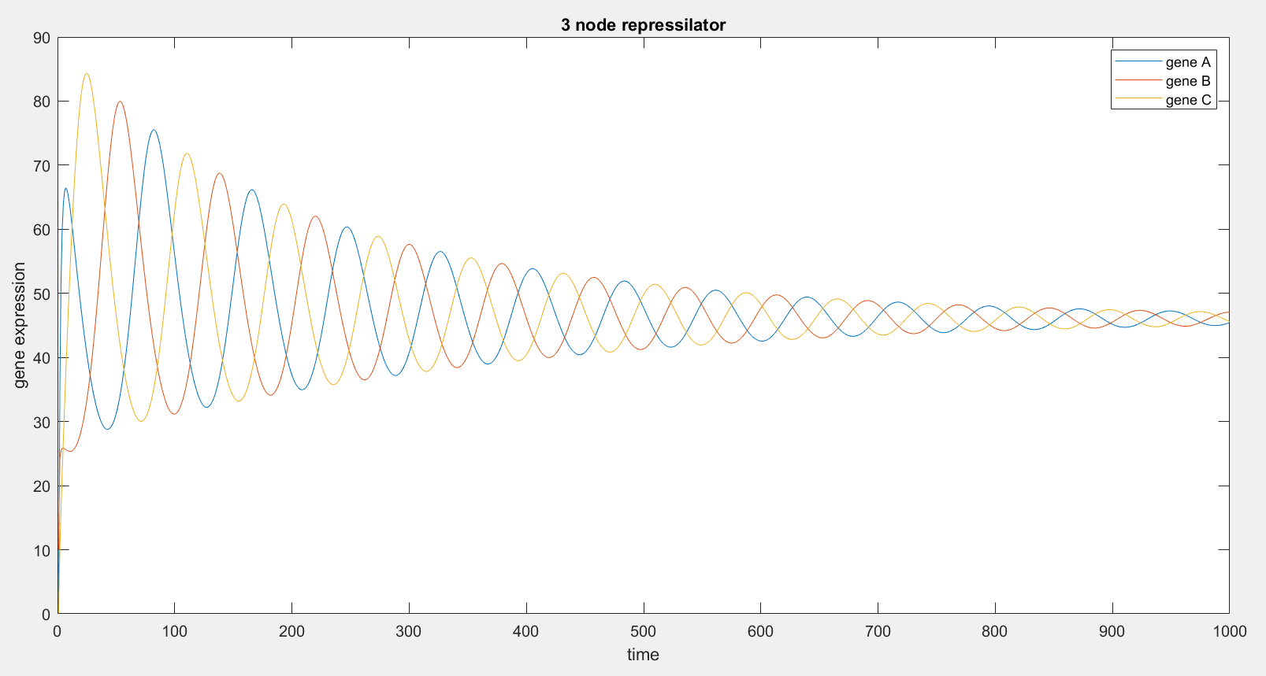

As we can see, this three node simulation has oscillations. Moreover, the amplitude of the oscillations is decaying. But, the time period of the oscillations remains fairly sustained at 80 time units.

b) I added another node to the previous model, to simulate a four node repressilator, with given conditions. The output is:

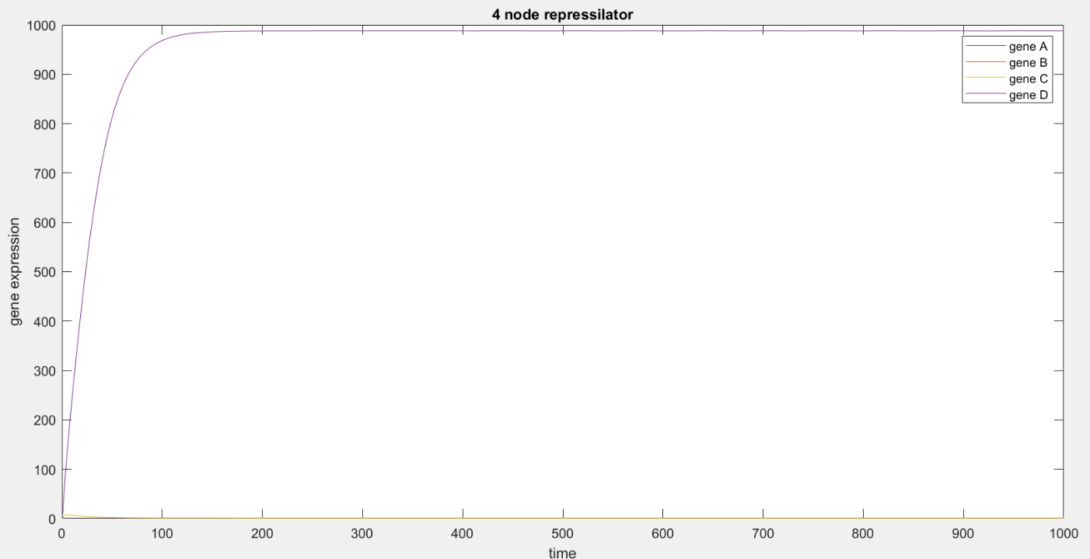

This simulation with four nodes shows a different behaviour. The newly introduced gene D has an exponential behaviour, whereas, the previous the genes shows a constant plot. Therefore, there is no oscillations for four node simulation.

c) Further by adding another node, I simulated a five node repressilator, with given conditions. The output is:

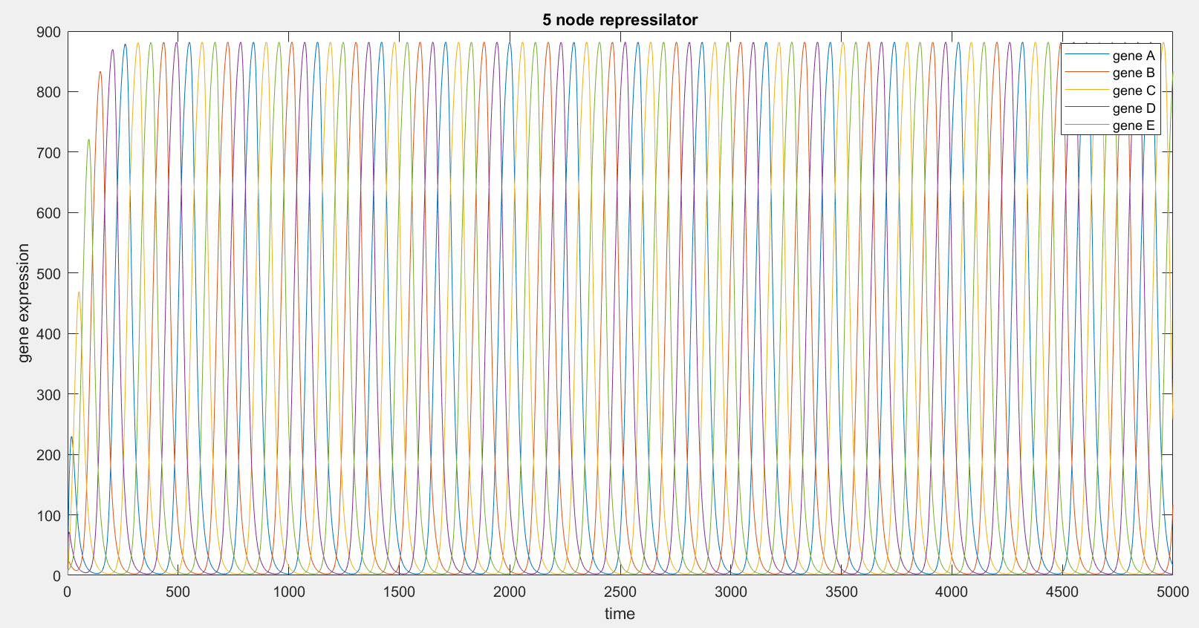

The five node repressilator expresses an interesting behaviour. Initially, every node has oscillations, but at different amplitudes and time period. But, after some time units, every node follows strict oscillations, with same time period and amplitude. The amplitude and time period are sustained.

Problem 3:

Using the concept of FSEOF, I identified 5 potential knockouts and 5 overexpressing targets. They are:

***Potential Knockouts:***

* {'ATP synthase mitochondrial'}
* {'CoA transporter mitochondrial irreversible'}
* {'Cytochrome c oxidase mitochondrial'}
* {'Ubiquinol 6 cytochrome c reductase'}
* {'Glycine hydroxymethyltransferase, reversible'}

***Overexpresions:***

* {'2 Dehydro 3 deoxy D arabino heptonate7 phohsphate mitochondrial transport via diffusion'}
* {'2 Isopropylmalate transport diffusion mitochondrial'}
* {'Adentylate kinase (GTP)'}
* {'Adentylate kinase (ITP)'}
* {'Aspartate transaminase'}